TECHNIQUES IN FASHION

Tack (sewing)

In sewing, to tack or baste is to make quick, temporary stitching intended to be removed. Tacking is used in a variety of ways:
- To temporarily hold a seam or trim in place until it can be permanently sewn, usually with a long running stitch made by hand or machine called atacking stitch or basting stitch.
- X-shaped tacking stitches are also very common on vents (slits) on the back of men's suit jackets, or at the bottom of kick pleats on a woman's skirt. They are meant to hold the flaps in place during shipping and when on display in the store. They should be removed before being worn; however many buyers do not realize it.^{[1][2]} Brand labels loosely basted on the outer edges of the sleeves of suits as well as women's winter coatshould also be removed after purchase. They are meant to help customers to easily identify the brands in the store without reaching into the collar.^{[3]}
- To temporarily attach a lace collar, ruffles, or other trim to clothing so that the attached article may be removed easily for cleaning or to be worn with a different garment. For this purpose, tacking stitches are sewn by hand in such a way that they are almost invisible from the outside of the garment.
- To transfer pattern markings to fabric, or to otherwise mark the point where two pieces of fabric are to be joined. A special loose looped stitch used for this purpose is called a tack or tailor's tack. This is often done through two opposing layers of the same fabric so that when the threads are snipped between the layers the stitches will be in exactly the same places for both layers thus saving time having to chalk and tack the other layer.
- A basting stitch is essentially a straight stitch, sewn with long stitches and unfinished ends. The basting stitch is used for temporarily holding sandwiched pieces of fabric in place. The stitch is removed after the piece is finished. Often used in quilting or embroidery.
- 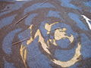
Basting thread on the right side (outer side) of fabric.

- 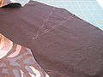
Tracing paper from a pattern is basted to fabric before a piece is cut. The basting marks are outlined with tailor's chalk.

Tailor's tacks mark fabric to trace a pattern piece, without attaching tracing paper.

External references
  - ^ Formal appearance and attire
  - ^ Quilters' Board: Tacking Stitch
  - ^ Fashion faux pas – Tags on sleeves
Tacking stitch

Cut (clothing)

Cut in clothing, sewing and tailoring, is the style or shape of a garment as opposed to its fabric or trimmings.
The cut of a coat refers to the way the garment hangs on the body based on the shape of the fabric pieces used to construct it, the position of the fabric's grain line, and so on.

Darning

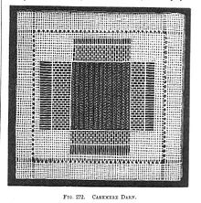
"Cashmere darn", a fine darning technique for twill fabric, from The Dictionary of Needlework, 1885.
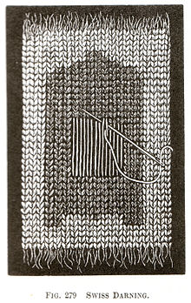
"Swiss darning" to repair knits
Darning is a sewing technique for repairing holes or worn areas in fabric or knitting using needle and thread alone. It is often done by hand, but it is also possible to darn with a sewing machine. Hand darning employs the darning stitch, a simple running stitch in which the thread is "woven" in rows along the grain of the fabric, with the stitcher reversing direction at the end of each row, and then filling in the framework thus created, as if weaving. Darning is a traditional method for repairing fabric damage or holes that do not run along a seam, and where patching is impractical or would create discomfort for the wearer, such as on the heel of a sock.
Darning also refers to any of several needlework techniques that are worked using darning stitches:
- Pattern darning is a type of embroidery that uses parallel rows of straight stitches of different lengths to create a geometric design.
- Net darning, also called filet lace, is a 19th century technique using stitching on a mesh foundation fabric to imitate lace.
- Needle weaving is a drawn thread work embroidery technique that involves darning patterns into barelaid warp or weft threads.

Darning cloth
In its simplest form, darning consists of anchoring the thread in the fabric on the edge of the hole and carrying it across the gap. It is then anchored on the other side, usually with a running stitch or two. If enough threads are criss-crossed over the hole, the hole will eventually be covered with a mass of thread.
Fine darning, sometimes known as Belgian darning, attempts to make the repair as invisible and neat as possible. Often the hole is cut into a square or darn blends into the fabric.
There are many varieties of fine darning. Simple over-and-under weaving of threads can be replaced by various fancy weaves, such as twills, chevrons, etc., achieved by skipping threads in regular patterns.
Invisible darning is the epitome of this attempt at restoring the fabric to its original integrity. Threads from the original weaving are unravelled from a hem or seam and used to effect the repair. Invisible darning is appropriate for extremely expensive fabrics and items of apparel.
In machine darning, lines of machine running stitch are run back and forth across the hole, then the fabric is rotated and more lines run at right angles. This is a fast way to darn, but it cannot match the effects of fine darning.

Darning tools
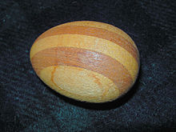
Darning egg, early 20th century
There are special tools for darning socks or stockings:
- A darning egg is an egg-shaped ovoid of stone, porcelain, wood, or similar hard material, which is inserted into the toe or heel of the sock to hold it in the proper shape and provide a firm foundation for repairs. When the repairs are finished, the darning egg is removed. A shell of the tiger cowryCypraea tigris, a popular ornament in Europe and elsewhere, was also sometimes used as a ready-made darning egg.
- A darning mushroom is a mushroom-shaped tool usually made of wood. The sock is stretched over the curved top of the mushroom, and gathered tightly around the stalk to hold it in place for darning.
- A darning gourd is a hollow dried gourd with a pronounced neck. The sock can be stretched over the full end of the gourd and held in place around the neck for darning.
- A used light bulb can be used to hold a sock in place for darning.

Pattern darning[edit]
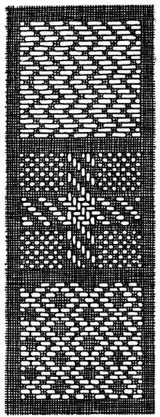
Pattern darning
Pattern darning is a simple and ancient embroidery technique in which contrasting thread is woven in-and-out of the ground fabric using rows of running stitches which reverse direction at the end of each row. The length of the stitches may be varied to produce geometric designs. Traditional embroidery using pattern darning is found in Africa, Japan, Northern and Eastern Europe, the Middle East, Mexico and Peru [1].
Pattern darning is also used as a filling stitch in blackwork embroidery.

References[edit]
- S.F.A. Caulfield and B.C. Saward, The Dictionary of Needlework, 1885.
- Readers Digest Complete Guide to Needlework, 1979, ISBN 0-89577-059-8.
- Reader's Digest Oxford Dictionary p.1001.CS.

External links[edit]
- Chapter 11—Darning and Patching from American Dressmaking Step by Step (1917) by Mme. Lydia Trattles Coates
- Pattern Darning by Sally Simon at the American Needlepoint Guild (examples and stitching techniques)
- Swiss darning as an embellishment technique

Dart (sewing)

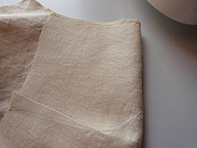
The reverse side of fabric showing where a dart has been taken in and stitched to tailor the shape of a garment to the wearer.
Darts are folds sewn into fabric to help provide a three-dimensional shape to a garment. They are frequently used in women's clothing to tailor the garment to the wearer's shape.
Two kinds of darts are common in blouses for women:
- Vertical darts—These are sewn from the bottom of the blouse to a point generally around the bustline. This type of dart may be found in the front, rarely in the back of a garment and are used by the garment maker to pull in the bottom of the blouse towards the wearer's waist.
- Bust darts—These are short triangle folds that provide space for breasts such that the fabric under the breasts isn't hanging, rather is fitting closer to the wearer. There are several subtypes of bust line dart:^{[1]}
  - Center
  - Waist
  - French
  - Side seam
  - Armhole
  - Neckline
  - Shoulder
  - T-dart
  - Inverted T-dart
In the early 1950s, the New York City firm of Evan-Picone pioneered the use of darts in the pockets of women's clothing. The darts help keep the pocket open and thus more easily accessed, reducing the chance of rips or tears.^{[2]}

References
  - ^ Calderin, Jay (2009). Form, Fit and Fashion. Rockport Publishers Inc. p. 131. ISBN 9781592535415.
  - ^ Hays, Constance. "Joseph Picone, 83, a Founder of Line of Women's Clothing." New York Times. June 26, 2001.

- princess seams

Embellishment

In sewing and crafts an embellishment is anything that adds design interest to the piece.

Common examples of embellishment in sewing and crafts
- appliqué
- embroidery, done either by machine or by hand
- piping made from either self-fabric, contrast fabric, or a simply a cord.
- trim (sewing)
- lace, either pre-made or home-made
- Fringe (trim)
- beads
- batique
Items that normally serve a function may also be used as embellishment. For example
- buttons can be placed anywhere on the piece
- zippers can be unzipped and be used as piping, or simply stitched on
- buckles can be placed anywhere on the piece
- grommets can be placed anywhere even when there is no cord is looped through them
- sequins can be placed anywhere

Fabric tube turning

Fabrics are often sewn inside out, in a tube form, or in a manner to allow a filler (such as cording) to be added. The process of turning the fabric tube has several variations.^{[1]} Fabric can be turned with a blunt item such as a bobbin or chopstick, or with purchased tools such as the Fasturn, Loop Turners, or Hemostats.^{[2]}

References
- ^ http://www.sewing.org/files/guidelines/1_150_tube_turners1.pdf
- ^ # Singer: The New Sewing Essentials by The Editors of Creative Publishing International ISBN 0-86573-308-2

Facing (sewing)

In sewing and tailoring, facing is fabric applied to a garment edge, on the inside. Shaped facings are cut to match the outside shape of the piece to provide a neat finish, and are often cut from the same pattern pieces. Shaped facings are typically made of the same fabric as the garment, but may also be made of lighter-weight fabric or in a contrasting color as a design element. Extended facings are extensions of the garment fabric, folded back and usually stabilized. Bias facings are strips of lightweight fabric cut on the true bias (US) or cross-grain (UK), and shaped rather than cut to match the edge to which they are applied.

Notes[edit]
  - ^ Picken (1957), p. 121
  - ^ Shaeffer (2007), pp. 72-73.

References
- Picken, Mary Brooks (1957). The Fashion Dictionary. Funk and Wagnalls.
- Shaeffer, Claire B. (2007). Couture Sewing Techniques. Taunton. ISBN 978-1-56158-497-0

Floating canvas
Floating canvas is a term used by tailors to describe the cloth-construction inside a jacket or coat. It consists of two layers of cloth into which horsehair has been woven, which are then sewntogether to create a curving of the finished canvas. This is then sewn into the front of a coat.

Gather (sewing)

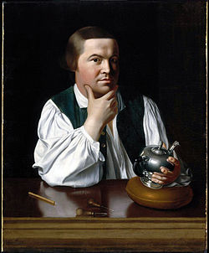
Paul Revere in a shirt gathered at shoulder and cuffs, 1776.
Gathering is a sewing technique for shortening the length of a strip of fabric so that the longer piece can be attached to a shorter piece. It is commonly used in clothing to manage fullness, as when a full sleeve is attached to the armscye or cuff of a shirt, or when a skirt is attached to abodice.
In simple gathering, parallel rows of running stitches are sewn along one edge of the fabric to be gathered. The stitching threads are then pulled or "drawn up" so that the fabric forms small folds along the threads.^{[1]} ^{[2]}
Gathering seams once tedious hand sewing of basting which was time consuming and inefficient with heavy fabric. Now, a quick and easy way to make a gather is to use a wide zigzag stitch. Both the upper and lower thread are pulled long and placed in front of the sewing machine. Then zigzagging is carefully sewed over top of the two threads without catching the threads as it is sewn. At the end the thread is pulled and is then gathered. ^{[3]}
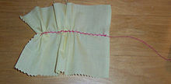
This photo shows a quick and easy method of machine gathering. This zigzag gathering technique is the strongest and most sturdy method of gathering.

Types
- Pleating or plaiting is a type of gathering in which the folds are usually larger, made by hand and pinned in place, rather than drawn up on threads, but very small pleats are often identical to evenly-spaced gathers. Pleating is mainly used to make skirts, but can have other uses.(See main article Pleat.)
- Shirring or gauging is a decorative technique in which a panel of fabric is gathered with many rows of stitching across its entire length and then attached to a foundation or lining to hold the gathers in place. It is very commonly used to make larger pieces of clothing with some shape to them.^{[5]}

References
- ^ Caulfield, S.F.A. and B.C. Saward, The Dictionary of Needlework, 1885, facsimile edition, Blaketon Hall, 1989, p. 219
- ^ Picken, Mary Brooks: The Fashion Dictionary, Funk and Wagnalls, 1957. (1973 edition ISBN 0-308-10052-2)
- ^ LovetoSew.com Garment Construction: How to Gather Fabric http://www.lovetosew.com/seamgathering.htm Retrieved on 2011-12-28
- ^ Caulfield and Saward, The Dictionary of Needlework
- ^ Caulfield and Saward, The Dictionary of Needlework, p. 220

Godet (sewing)

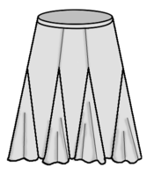
A skirt with godets on the seams.
A godet (/ɡoʊˈdeɪ/ or /ɡoʊˈdɛt/)^{[1]} is an extra piece of fabric in the shape of a circular sector which is set into a garment, usually a dress or skirt.^{[2]} The addition of a godet causes the article of clothing in question to flare, thus adding width and volume.^{[3]} Adding a godet to a piece of clothing also gives the wearer a wider range of motion.^{[4]}

See also
- Gore (segment)
- Gusset
- Pleat

References
  - ^ "godet". Oxford English Dictionary (3rd ed.). Oxford University Press. September 2005.
  - ^ Wolff, Colette (1996). The art of manipulating fabric. KP Craft. ISBN 978-0-8019-8496-9.
  - ^ Silverman, Julia E. (1942). Power Machine Sewing. R.R. Smith.
  - ^ Pepin, Harriet (1997). "1942-Modern Pattern Design". VintageSewing.info. Retrieved 2009-08-13.

Gore (segment)

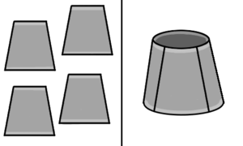

Four flat gores of cloth and a three-dimensional skirt constructed from such gores.
A gore is a segment of a three-dimensional shape fabricated from a two-dimensional material.^{[1]} The term was originally used to describe triangular shapes, but is now extended to any shape that can be used to create the third dimension.

Examples
A parachute and hot air balloon, both constructed from gores of material
- Spherical globes of the Earth and Celestial sphere were first mass-produced by Johannes Schöner using a process of printing map details on 12 paper gores that were cut out then pasted to a sphere. This process is still often used. The gores are conveniently made to each have a width of 30 degrees of longitude matching the principal meridians from the South Pole and North Pole to the Equator.
- Parachutes and hot air balloons are made from gores of lightweight material. The gores are cut from flat material, and stitched together to create various shapes.
- Corners in round duct-work can be created by welding or fixing gores of metal sheet to form a bend.
- Some designers use the stretched grid method to design gores that are cut out of weather-resistant fabric and then stitched together to form fabric structures.

Gusset

This article is about the piece of fabric. For the component of medieval armor, see gousset. For engineering gussets, see gusset plate.
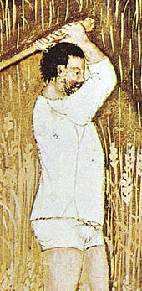
Late medieval shirt with gussets in the seams at shoulder, underarm, and hem.
In sewing, a gusset is a triangular or rhomboid piece of fabric inserted into a seam to add breadth or reduce stress from tight-fitting clothing. Gussets were used at the shoulders, underarms, and hems of traditional shirts and chemises made of rectangular lengths of linen to shape the garments to the body.^{[1][2]}
Gussets are used in manufacturing of modern tights or pantyhose to add breadth at the crotch seam; these gussets are often made of breathable fabrics forhygiene when wearing pantyhose without underwear.
The term "don't bust a gusset" comes from this sewing term; a gusset in this context was usually a piece of fabric sewn between two others to increase mobility or increase the size of the pant waist, the latter being more common in the early 1900s.^{[citation needed]}
Gussets are also used when making three-piece bags. In a Boye Needle Company publication,^{[3]} it is used in a pattern for a bag as a long, wide piece which connects the front piece and back piece. By becoming the sides and bottom of the bag, the gusset opens the bag up beyond what simply attaching the front to the back would do. With reference to the dimension of the gusset, the measurements of a flat bottom bag may be quoted as LxWxG.

References
  - ^ Burnham, Dorothy, Cut My Cote, Royal Ontario Museum, 1973.
  - ^ Sturm, Mary Mark (1973). Guide to modern clothing (3rd ed.). Webster Division, McGraw-Hill. ISBN 0070622930.
  - ^ I taught myself to crochet. No. 7702. Freeport, Illinois: Boye Needle Company. 1975. OCLC 51565050.
  - ^ Ozepac Catalogue

Hem

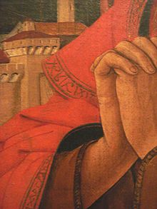
Hem detail with inscriptions, Saint-John in Crucifixion, Ferrara, by Vicino da Ferrara(1469–70).
A hem in sewing is a garment finishing method, where the edge of a piece of cloth is folded narrowly and sewn to prevent unravelling of the fabric.

Methods
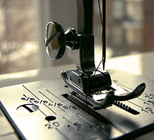
A presser foot on a home sewing machine includes measurement markings on the plate beneath the foot for easier hemming. Shown are measurements in fractions of an inch (above) and in millimetres (below).
There are many different styles of hems of varying complexities. The most common hem folds up a cut edge, folds it up again, and then sews it down. The style of hemming thus completely encloses the cut edge in cloth, so that it cannot unravel. Other hem styles use fewer folds. One of the simplest hems encloses the edge of cloth with a stitch without any folds at all, using a method called an overcast stitch, although an overcast stitch may be used to finish a folded "plain hem" as well.^{[1]}
There are even hems that do not call for sewing, instead using iron-on materials, netting, plastic clips, or other fasteners.^{[2]} These threadless hems are not common, and are often used only on a temporary basis.
The hem may be sewn down with a line of invisible stitches or blind stitch, or sewn down by a sewing machine. The term hem is also extended to other cloth treatments that prevent unraveling. Hems can be serged (see serger), hand rolled and then sewn down with tiny stitches (still seen as a high-class finish to handkerchiefs), pinked with pinking shears, piped, covered with binding (this is known as a Hong Kong finish), or made with many other inventive treatments.
Most haute couture hems are sewn by hand. Decorative embroidery embellishment is sometimes referred to as a hem-stitch design.

Types of hems and hem stitches
Hems of different depths (which includes the seam allowance) may have a particular style to achieve, which requires more or less fabric depending upon the style. A handkerchief-style edge requires a hem allowance of 0.6 cm or a quarter inch. A typical skirt or pant hem may be 5-7.6 cm.^{[3]} The hem's depth affects the way the fabric of the finished fabric will drape. Heavier fabric requires a relatively shorter hem.^{[4]} An interface fabric sewn to the fabric in the hem has a useful function in some hem styles. A bias strip is sometimes used as a hem interface. This adds fullness to the finished garment and reduce wrinkling.^{[5]}
The hem stitches that are commonly used for hand-sewn hems include: pick stitch; catch stitch (also called a herringbone stitch); slip stitch; and blind stitch.^{[6]}
Sewing machines can make a stitch that appears nearly invisible by using a blind-stitch setting and a blind stitch foot. Blind-stitches are commonly used to finish hems of applique designs on fabric.^{[7]} Modern sewing machines designed for home use can make many decorative or functional stitches, so the number of possible hem treatments is large. These home-use machines can also sew a reasonable facsimile of a hem-stitch, though the stitches will usually be larger and more visible.
Clothing factories and professional tailors use a "blind hemmer", or hemming machine, which sews an invisible stitch quickly and accurately. A blind hemmer sews a chain stitch, using a bent needle, which can be set precisely enough to actually sew through one and a half thicknesses of the hemmed fabric. A rolled hem presser foot on a sewing machine^{[8]} enables quick and easy hemming even by home sewers.
Heavy material with deep hems may be hemmed with what is called a dressmaker's hem​—​an extra line of loose running stitch is added in the middle of the hem, so that all the weight of the cloth does not hang from one line of stitching.
- 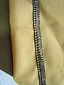
A five-thread overlock hem made with a sergermachine. This photo shows the inside of the garment. On the outside of the garment, this would appear as a blind stitch.

- 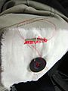
A buttonhole stitch hems the opening around a button hole.

A pick stitch hem made with thread that matches the fabric, to appear invisible on the outside of the garment.

- 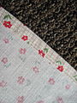
A plain hem, folded once and sewn with a running stitch.

Hem repair
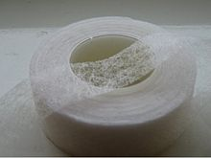
Hem repair tape
Hem repair tape is available as an alternative solution to sewing a broken hem. To effect a fix, the hem repair tape is laid around the inside of the hem. It is then ironed with a hot iron. The heat causes the tape to bond the two surfaces together.

References
  - ^ Shaeffer, Clare B. (2011). Couture Sewing Techniques. Taunton Press. pp. 69–70. ISBN 9781600853357.
  - ^ Calderin, Jay (2009). Form, Fit and Fashion. Rockport Publishing, Inc. p. 184. ISBN 9781592535415.
  - ^ Calderin, Jay (2009). Form, Fit and Fashion. Rockport Publishing, Inc. p. 184. ISBN 9781592535415.
  - ^ Colgrove, Debbie (2011). "12 Hemming techniques". Teach Yourself VISUALLY Sewing. John Wiley & Sons. pp. N.p. ISBN 9781118153376.
  - ^ Shaeffer, Clare B. (2011). Couture Sewing Techniques. Taunton Press. pp. 69–72. ISBN 9781600853357.
  - ^ Calderin, Jay (2009). Form, Fit and Fashion. Rockport Publishing, Inc. p. 184. ISBN 9781592535415.
  - ^ Shaeffer, Clare B. (2011). Couture Sewing Techniques. Taunton Press. pp. 69–70. ISBN 9781600853357.
  - ^ Calderin, Jay (2009). Form, Fit and Fashion. Rockport Publishing, Inc. p. 184. ISBN 9781592535415.

Heirloom sewing

Heirloom sewing is a collection of needlework techniques that arose in the last quarter of the 20th century that imitates fine French hand sewing of the period 1890-1920 using a sewing machineand manufactured trims.^{[1]}
Heirloom sewing is characterized by fine, often sheer, usually white cotton or linen fabrics trimmed with an assortment of lace, insertions, tucks, narrow ribbon, and smocking, imitating such hand-work techniques as whitework embroidery, Broderie Anglaise, and hemstitching.
Typical projects for heirloom sewing include children's garments (especially christening gowns), women's blouses, wedding gowns, and lingerie.

Notes
  - ^ Ahles, Carol Laflin: Fine Machine Sewing, p. 115

References[edit]
- Ahles, Carol Laflin: Fine Machine Sewing Revised Edition: Easy Ways to Get the Look of Hand Finishing and Embellishing, Taunton Press, rev'd ed. 2003, ISBN 1-56158-586-6
- Pullen, Martha: French Hand Sewing by Machine: The Second Book, Martha Pullen Co (January 1985), ISBN 9999840329

Lining (sewing)

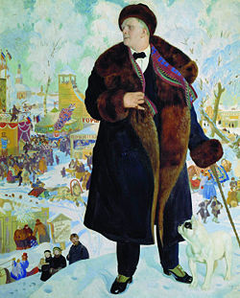
Russian opera singer Feodor Chaliapin in a fur-lined coat. Portrait by Boris Kustodiyev, 1921.
In sewing and tailoring, a lining is an inner layer of fabric, fur, or other material inserted into clothing, hats, luggage, curtains, handbags and similar items.
Linings provide a neat inside finish and conceal interfacing, padding, the raw edges of seams, and other construction details. A lining reduces the wearing strain on clothing, extending the useful life of the lined garment. A smooth lining allows a coat or jacket to slip on over other clothing easily, and linings add warmth to cold-weather wear.
Linings are typically made of solid colors to coordinate with the garment fabric, but patterned and contrasting-colored linings are also used. Designer Madelaine Vionnet introduced the ensemble in which the coat was lined in the fabric used for the dress worn with it,^{[3]} and this notion remains a characteristic of the Chanel suit, which often features a lining and blouse of the same fabric.
In tailoring, home sewing, and ready-to-wear clothing construction, linings are usually completed as a unit before being fitted into the garment shell. In haute couture, the sleeves and body are usually lined separately before assembly.
- An interlining is an additional layer of fabric between the lining and the outer garment shell. Insulating interlinings for winter garments are usually sewn to the individual lining pieces before the lining is assembled.
- A partial or half lining lines only the upper back and front of the garment, concealing the shoulder pads and interfacings,^{[7]} with or without sleeves.
- A zip-in, zip-out, snap-out or button-in lining (sometimes liner) is a warm removable lining for a jacket, coat, or raincoat that is held in place with a zipper, snap fasteners, or buttons. Garments with removable linings are usually lined with a lightweight fabric as well, to provide a neat finish when the warm lining is not worn.

- 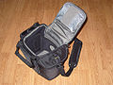
Camera bag with contrasting padded and fitted lining

- 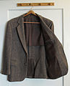
Tailored sport coat with partial lining

Notes
  - ^ Editors of Creative Publishing (2005), pp. 24, 106
  - ^ Shaeffer (2007), p. 176
  - ^ Brockman (1965), p. 40
  - ^ Shaeffer (2007), p. 182
  - ^ Shaeffer (2007), p. 176
  - ^ Editors of Creative Publishing (2005), p. 111
  - ^ Editors of Creative Publishing (2005), p. 58

References
- Brockman, Helen L. (1965).

Pleat

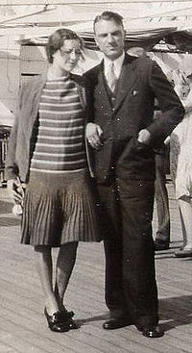
Skirt with narrow knife pleats at the hip line, 1929.
A pleat (older plait) is a type of fold formed by doubling fabric back upon itself and securing it in place. It is commonly used in clothing and upholstery to gather a wide piece of fabric to a narrower circumference.^{[1]}
Pleats are categorized as pressed, that is, ironed or otherwise heat-set into a sharp crease, or unpressed, falling in soft rounded folds.
Pleats sewn into place are called tucks.

Fullness
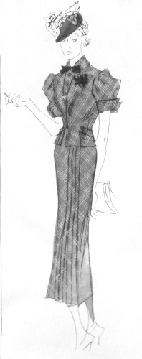
Spring dress of chiffon with pleated skirt detail, 1936. Pleats to allow movement in narrow skirts have been a recurring theme in fashion since the later 19th century.
A vertically hanging piece of fabric such as a skirt or a drape will often be described in terms of its "fullness." Fullness represents the thickness/ depth of the pleats in relation to the original width of the fabric: fabric sewn at "zero fullness" is flat and has no pleats; fabric sewn at "100% fullness" is pleated so that it takes up exactly half as much width as it would if it were not pleated at all (i.e., 24 inches would be pleated down to 12 inches); if sewn at "150% fullness," the unpleated fabric would be two and a half times wider than the final pleated piece (i.e., an unpleated 30 inches would end up as 12 pleated inches of fabric– 12+1.50(12)=30); if fullness were to be "50%", the original fabric would be one and a half times the width of the pleated (i.e., 18 inches of width would end up as 12 pleated inches– 12+0.50(12)=18), etc.

Types of pleats
- Accordion pleating is a form of tight pleating which allows the garment to expand its shape when moving. Accordion pleating is also used for some dress sleeves, such as pleating the end of the elbow, with the fullness of the pleat gathered closely at the cuff. This form of pleating inspired the "skirt dancing" of Loie Fuller.^{[2]} Accordion pleats may also be used in hand fans.
- Box pleats are knife pleats back-to-back, and have a tendency to spring out from the waistline.^{[3]} They have the same 3:1 ratio as knife pleats, and may also be stacked to form stacked box pleats. These stacked box pleats create more fullness and have a 5:1 ratio. They also create a bulkier seam.Inverted box pleats have the "box" on the inside rather than the outside.
- Cartridge pleats are used to gather a large amount of fabric into a small waistband or armscye without adding bulk to the seam. This type of pleating also allows the fabric of the skirt or sleeve to spring out from the seam. During the 15th and 16th centuries, this form of pleating was popular in the garments of men and women. Fabric is evenly gathered using two or more lengths of basting stitches, and the top of each pleat is whipstitched onto the waistband or armscye. Cartridge pleating was resurrected in the 1840s to attach the increasingly full bell-shaped skirts to the fashionable narrow waist.
- Fluted pleats or flutings are very small, rounded or pressed pleats used as trimmings.^{[7]} The name comes from their resemblance to a pan flute.
- Fortuny pleats are crisp pleats set in silk fabrics by designer Mariano Fortuny in the early 20th century, using a secret pleat-setting process which is still not understood.
- Honeycomb pleats are narrow, rolled pleats used as a foundation for smocking.
- Knife pleats are used for basic gathering purposes, and form a smooth line rather than springing away from the seam they have been gathered to. The pleats have a 3:1 ratio–three inches of fabric will create one inch of finished pleat. Knife pleats can be recognized by the way that they overlap in the seam.^{[3]}
- Organ pleats are parallel rows of softly rounded pleats resembling the pipes of a pipe organ. Carl Köhler^{[8]} suggests that these are made by inserting one or more gores into a panel of fabric.
- Plissé pleats are narrow pleats set by gathering fabric with stitches, wetting the fabric, and "setting" the pleats by allowing the wet fabric to dry under weight or tension. Linen chemises or smocks pleated with this technique have been found in the 10th century Viking graves in Birka.
- Rolled pleats create tubular pleats which run the length of the fabric from top to bottom. A piece of the fabric to be pleated is pinched and then rolled until it is flat against the rest of the fabric, forming a tube. A variation on the rolled pleat is the stacked pleat, which is rolled similarly and requires at least five inches of fabric per finished pleat. Both types of pleating create a bulky seam.
- Watteau pleats are one or two box pleats found at the back neckline of 18th century sack-back gowns and some late 19th century tea gowns in imitation of these. The term is not contemporary, but is used by costume historians in reference to these styles as portrayed in the paintings of Antoine Watteau.^{[10]}
- 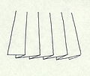
The knife pleat is the basic pleat used in sewing.

- 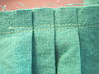
Knife pleats with the construction and seam stitches shown.

Box pleats for a skirt.

Modern usage
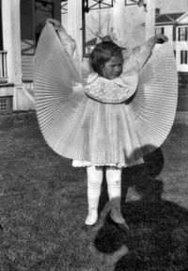
Girl holding pleated skirt
Clothing features pleats for practical reasons (to provide freedom of movement to the wearer) as well as for purely stylistic reasons.

Shirts, blouses, jackets
Shirts and blouses typically have pleats on the back to provide freedom of movement and on the arm where the sleeve tapers to meet the cuff. The standard men's shirt has a box pleat in the center of the back just below the shoulder or alternately one simple pleat on each side of the back.
Jackets designed for active outdoor wear frequently have pleats (usually inverted box pleats) to allow for freedom of movement. Norfolk jackets have double-ended inverted box pleats at the chest and back.

Skirts and kilts
Skirts, dresses and kilts can include pleats of various sorts to add fullness from the waist or hips, or at the hem, to allow freedom of movement or achieve design effects.
- One or more kick pleats may be set near the hem of a straight skirt to allow the wearer to walk comfortably while preserving the narrow style line.
- Modern kilts may be made with either box pleats or knife pleats, and can be pleated to the stripe or pleated to the sett (see main article Kilts: Pleating and stitching).

Trousers
Pleats just below the waistband on the front of the garment are typical of many styles of formal and casual trousers including suit trousers and khakis. There may be one, two, three, or no pleats, which may face either direction. When the pleats open towards the pockets they are called reverse pleats (typical of khakis and corduroy trousers) and when they open toward the zipper, they are known as forward pleats.
Utilitarian or very casual styles such as jeans and cargo pants are flat-front (without pleats at the waistband) but may have bellows pockets.

Pockets
A bellows pocket is patch pocket with an inset box pleat to allow the pocket to expand when filled. Bellows pockets are typical of cargo pants, safari jackets, and other utilitarian garments.

Gallery
- 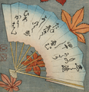
1 – Accordion pleats

- 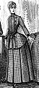
2 – Box pleats

- 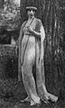
3 – Fortuny pleats

- 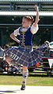
4 – Knife pleats

5 – Organ pleats

- 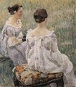
6 – Watteau pleats
- Painting of accordion pleated folding fan, Japan, 19th century
- Afternoon costume with box pleated skirt and unpressed box pleated bodice panel, France, 1886
- Fortuny pleated tea gown, 1917
- Knife-pleated kilt with pleats sewn down to the hip line, 2005
- Organ pleated gown, Florentine, 1470
- Tea gowns with Watteau-pleated backs, Russia, 1899

Notes
- ^ Picken, Mary Brooks, The Fashion Dictionary, Funk and Wagnalls, 1957, pp. 256–257
- ^ Valerie Cumming; Valerie Cumming, C.W. Cunnington, P. E. Cunnington; C. W. Cunnington; P. E. Cunnington (1 September 2010). The Dictionary of Fashion History. Berg. p. 1. ISBN 978-1-84788-738-2. Retrieved 10 January 2012.
- ^ ª ^{b} Picken, Mary Brooks, The Fashion Dictionary, p. 257
- ^ Tozer, Jane and Sarah Levitt, Fabric of Society: A Century of People and their Clothes 1770–1870, Laura Ashley Press
- ^ Arnold, Janet: Patterns of Fashion: the cut and construction of clothes for men and women 1560–1620, Macmillan 1985
- ^ Arnold, Janet: Patterns of Fashion 1 (cut and construction of women's clothing, 1660–1860), Wace 1964, Macmillan 1972.
- ^ Caulfield and Saward, The Dictionary of Needlework, p. 212
- ^ Köhler, Carl: A History of Costume, Dover Publications reprint, 1963
- ^ Owen-Crocker, Gale R., Dress in Anglo-Saxon Englandrevised edition, Boydell Press, 2004, ISBN 1-84383-081-7, p. 42, 218
- ^ Picken, Mary Brooks, The Fashion Dictionary, pp. 257, 370

References
- Arnold, Janet: Patterns of Fashion: the cut and construction of clothes for men and women 1560–1620, Macmillan 1985. Revised edition 1986. ISBN 0-89676-083-9
- Arnold, Janet: Patterns of Fashion 1 (cut and construction of women's clothing, 1660–1860), Wace 1964, Macmillan 1972. Revised metric edition, Drama Books 1977. ISBN 0-89676-026-X.
- Kohler, Carl: A History of Costume, Dover Publications reprint, 1963, ISBN 0-486-21030-8
- Owen-Crocker, Gale R., Dress in Anglo-Saxon Englandrevised edition, Boydell Press, 2004, ISBN 1-84383-081-7
- Picken, Mary Brooks, The Fashion Dictionary, Funk and Wagnalls, 1957. (1973 edition ISBN 0-308-10052-2)
- Tozer, Jane and Sarah Levitt, Fabric of Society: A Century of People and their Clothes 1770–1870, Laura Ashley Press, ISBN 0-9508913-0-4
- Carol Reed:The Colour of Murder

- Several types of pleats used in historical costuming
- The Fortuny Gown

Ruffle

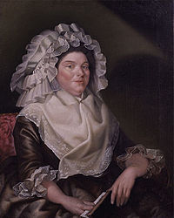
Portrait of a woman wearing a heavily ruffled cap, 1789
In sewing and dressmaking, a ruffle, frill, or furbelow is a strip of fabric, lace or ribbon tightly gathered or pleated on one edge and applied to a garment,bedding, or other textile as a form of trimming.^{[1]}
The term flounce is a particular type of fabric manipulation that creates a similar look but with less bulk. The term derives from earlier terms of frounce or fronce.^{[2]} A wavy effect effected without gathers or pleats is created by cutting a curved strip of fabric and applying the inner or shorter edge to the garment. The depth of the curve as well as the width of the fabric determines the depth of the flounce. A godet is a circle wedge that can be inserted into a flounce to further deepen the outer floating wave without adding additional bulk at the point of attachment to the body of the garment, such as at the hemline, collar or sleeve.
Ruffles appeared at the draw-string necklines of full chemises in the 15th century, evolved into the separately-constructed ruff of the 16th century. Ruffles and flounces remained a fashionable form of trim, off-and-on into modern times.^{[3]}

Notes
  - ^ Caulfield, S.F.A. and B.C. Saward, The Dictionary of Needlework, 1885, facsimile edition, Blaketon Hall, 1989, p. 428
  - ^ Caulfield and Saward, The Dictionary of Needlework, p. 218
  - ^ For styles and construction of ruffles, frills and flounces through the centuries, see the Arnold, Baumgarten and Tozer volumes listed below

References
- Oxford English Dictionary
- Picken, Mary Brooks: The Fashion Dictionary, Funk and Wagnalls, 1957. (1973 edition ISBN 0-308-10052-2)
- Arnold, Janet: Patterns of Fashion: the cut and construction of clothes for men and women 1560-1620, Macmillan 1985. Revised edition 1986. (ISBN 0-8967-6083-9)
- Baumgarten, Linda: What Clothes Reveal: The Language of Clothing in Colonial and Federal America, Yale University Press, 2002. ISBN 0-300-09580-5
- Tozer, Jane and Sarah Levitt, Fabric of Society: A Century of People and their Clothes 1770-1870, Laura Ashley Press, ISBN 0-9508913-0-4

Shirring

.
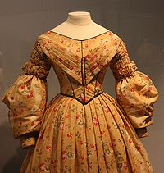
This cotton day dress of 1836–40 features shirring on the upper sleeves.Victoria and Albert Museum.
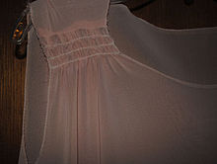
Here is a close-up of shirring done on the shoulder area during the garment construction from a 1925 vintage dress pattern. Photo provided by Love to Sew Studio
In sewing, shirring is two or more rows of gathers used to decorate parts of garments, usually the sleeves, bodice or yoke. The term is also sometimes used to refer to the pleats seen in stage curtains.
Shirring is a method of shaping a garment and is done so by controlling fullness. Its technique is similar to gathering. Shirring consists of two or more rows of gathered fabric. Shirring can be a pretty and feminine alternative to darts in small areas of a garment. Shirring can also be done on large areas of a garment like all around the top of a full skirt. Shirring works best on soft fabrics but can also done on stronger fabrics.^{[2]}

- Gather (sewing)
- Godet (sewing)
- Pleat

References
  - ^ Love to Sew Studio
  - ^ LovetoSew.com "Garment Construction: How to Sheer Fabric". Retrieved on 2011-12-27

Style line

- A style line is a line or curve in a garment that has a visual effect, e.g., the seam between two fabrics of different colors or textures. For comparison, a nearly invisible seam, such as a dart or pleat, would not be considered a style line. A style line is a boundary between two distinguishable areas of fabric, or a visible edge of fabric such as the neckline, waistline or hemline.
- As the term is generally used in practice, a style line is introduced only for fashion or cosmetic purposes. However, a style line may also fulfill a shaping function as a dart, a seam at which a dart may end, or as a way of hiding details of the garment's construction.

